WEB DEVELOPMENT INTERNSHIP
AN INTERNSHIP PROJECT REPORT
Submitted by
SANJAY R
(Reg. No: 110725102218)
in partial fulfilment of the requirements for the award of the degree of
BACHELOR OF TECHNOLOGY
IN
ARTIFICIAL INTELLIGENCE AND DATA SCIENCE

J.N.N Institute of Engineering
(An Autonomous Institute, Affiliated to Anna University, Chennai)
AUGUST 2026 – 2027
VISION OF THE INSTITUTE:
Lead the transformation of engineering and management learning experience to educate the next generation of innovators and entrepreneurs who want to make the world a better place.

MISSION OF THE INSTITUTE:
IM1: To develop the required resources and infrastructure and to establish a conducive ambience for the teaching-learning process.
IM2: To nurture professional and ethical values in the students and to instil in them a spirit of innovation and entrepreneurship.
IM3: To encourage a desire for higher learning and research in the students and to equip them to face global challenges.
IM4: To provide opportunities for students to learn job-relevant skills to make them industry ready.
IM5: To interact with industries and other organizations to facilitate transfer of knowledge and know-how.

VISION OF THE DEPARTMENT:
To impart quality education, inculcate professionalism and enhance the problem-solving skills of the students in the domain of Artificial Intelligence and Data Science by applying recent technological tools and incorporating collaborative principles with a focus to make them industry ready.

MISSION OF THE DEPARTMENT:
DM1: To enhance the knowledge of the students with the most recent advancements and refresh their insights in the field of Artificial Intelligence and Data Science.
DM2: To equip the students with strong fundamental concepts, analytical capability, programming and problem-solving skills.
DM3: To make the students industry ready and to enhance their employability through training, internships and real-time projects.
DM4: To guide the students to perform research on Artificial Intelligence and Data Science, with the aim to provide solutions to the problems of the industry.
PROGRAM OUTCOMES (PO)
S.No | Graduate Attribute | Program Outcomes
PO1 | Engineering knowledge | Apply the knowledge of mathematics, science, engineering fundamentals, and an engineering specialization to the solution of complex engineering problems.
PO2 | Problem analysis | Identify, formulate, review research literature, and analyze complex engineering problems reaching substantiated conclusions using first principles of mathematics, natural sciences, and engineering sciences.
PO3 | Design/Development of solutions | Design solutions for complex engineering problems and design system components or processes that meet the specified needs with appropriate consideration for the public health and safety, and the cultural, societal, and environmental considerations.
PO4 | Conduct investigations of complex problems | Use research-based knowledge and research methods including design of experiments, analysis and interpretation of data, and synthesis of the information to provide valid conclusions.
PO5 | Modern tool usage | Create, select, and apply appropriate techniques, resources, and modern engineering and IT tools including prediction and modeling to complex engineering activities with an understanding of the limitations.
PO6 | The engineer and society | Apply reasoning informed by the contextual knowledge to assess societal, health, safety, legal and cultural issues and the consequent responsibilities relevant to the professional engineering practice.
PO7 | Environment and sustainability | Understand the impact of the professional engineering solutions in societal and environmental contexts, and demonstrate the knowledge of, and need for sustainable development.
PO8 | Ethics | Apply ethical principles and commit to professional ethics and responsibilities and norms of the engineering practice.
PO9 | Individual and team work | Function effectively as an individual, and as a member or leader in diverse teams, and in multidisciplinary settings.
PO10 | Communication | Communicate effectively on complex engineering activities with the engineering community and with society at large, such as, being able to comprehend and write effective reports and design documentation, make effective presentations, and give and receive clear instructions.
PO11 | Project management and finance | Demonstrate knowledge and understanding of the engineering and management principles and apply these to one’s own work, as a member and leader in a team, to manage projects and in multidisciplinary environments.
PO12 | Life-long learning | Recognize the need for, and have the preparation and ability to engage in independent and life-long learning in the broadest context of technological change.
PROGRAM EDUCATIONAL OBJECTIVES (PEO)
S.No | Program Educational Objectives (PEO)
PEO1 | To provide graduates with the proficiency to utilize the fundamental knowledge of basic sciences, mathematics, Artificial Intelligence, data science and statistics to build systems that require management and analysis of large volume of data.
PEO2 | To enrich graduates with necessary technical skills to pursue pioneering research in the field of AI and Data Science and create disruptive and sustainable solutions for the welfare of ecosystems.
PEO3 | To enable graduates to think logically, pursue lifelong learning and collaborate with an ethical attitude in a multidisciplinary team.
PROGRAM SPECIFIC OBJECTIVES (PSO)
S.No | Program Specific Objectives (PSO)
PSO1 | Graduates should be able to evolve AI-based efficient domain-specific processes for effective decision making in several domains such as business and governance domains.
PSO2 | Graduates should be able to arrive at actionable foresight, insight, and hindsight from data for solving business and engineering problems.
PSO3 | Graduates should be able to create, select and apply the theoretical knowledge of AI and Data Analytics along with practical industrial tools and techniques to manage and solve wicked societal problems.

BONAFIDE CERTIFICATE
Certified that this internship project report entitled “WEB DEVELOPMENT INTERNSHIP – PERSONAL PORTFOLIO WEBSITE DEVELOPMENT” is the bonafide work of SANJAY R (REG. NO: 110725102218), who carried out the internship project work under the supervision of the Department of Artificial Intelligence and Data Science, J.N.N Institute of Engineering, Chennai.
Signature of the HOD with date | Signature of the Supervisor with date
Dr. P. Nagarajan  Professor and Head,  Department of Artificial Intelligence  and Data Science,  J.N.N Institute of Engineering, Chennai. | Mrs. S. Brindha  Faculty Supervisor,  Department of Artificial Intelligence  and Data Science,  J.N.N Institute of Engineering, Chennai.
Certified that the above student has attended the viva voce examination held on …………………….
INTERNAL EXAMINER | EXTERNAL EXAMINER

ACKNOWLEDGEMENT
First and foremost, I express my sincere gratitude to our beloved FOUNDER & CHAIRMAN Shri. S. JAYACHANDRAN, B.Sc., B.L., and also offer my heartfelt thanks to our VICE CHAIRMAN Mr. NAVEEN JAYACHANDRAN, M.S., for providing the necessary facilities for the completion of this internship project.
I thank our PRINCIPAL Dr. G. MOHANBABU, Ph.D., for the encouragement and the congenial environment provided, which were essential for me to complete this project.
I take this opportunity to express my gratitude to our HEAD OF THE DEPARTMENT Dr. P. NAGARAJAN and all the other faculty members of the Department of Artificial Intelligence and Data Science for their continuous encouragement in completing this project.
I extend my sincere thanks to my faculty supervisor, Mrs. S. BRINDHA, for her guidance and support during the preparation of this internship report.
I am grateful to Wiztech Automation Solutions, Anna Nagar, Chennai, for providing me with the opportunity to undertake a Web Development internship. The internship helped me gain practical exposure to website development using HTML, CSS, and JavaScript and improve my technical and problem-solving skills.
Finally, I express my heartfelt thanks to my parents and friends for their constant encouragement, motivation, and support throughout the completion of this internship and project report.

ABSTRACT
Web development plays an important role in creating interactive, user-friendly, and responsive websites for personal and professional use. This report presents the work carried out during the Web Development Internship at Wiztech Automation Solutions, Anna Nagar, Chennai, from 1st August 2026 to 17th August 2026.
The main objective of this internship was to gain practical knowledge of web development and apply the concepts learned through hands-on implementation. During the internship, HTML, CSS, and JavaScript were used to develop a personal portfolio website that presents personal information, educational background, technical skills, projects, certifications, and contact details.
The portfolio website was designed to provide a clear and organised presentation of academic achievements and technical capabilities. The development process involved structuring web pages using HTML, styling and layout design using CSS, and implementing interactive elements using JavaScript. The project also provided practical experience in using Visual Studio Code for development and GitHub for version control and project hosting.
Throughout the internship, challenges related to CSS alignment, responsive design, and JavaScript functionality were addressed through testing, debugging, and continuous improvement. The internship strengthened my understanding of website development and improved my coding, problem-solving, and independent learning skills.
Overall, this internship provided valuable practical exposure to web development and helped me build a personal portfolio website to showcase my skills and projects in a professional manner.

TABLE OF CONTENTS

CHAPTER NO. | TITLE | PAGE NO.
1 | INTRODUCTION | 10
 | 1.1 Overview | 10
 | 1.2 Internship Details | 10
 | 1.3 Objectives | 11
 | 1.4 Overview of the Project | 11
2 | LITERATURE REVIEW | 12
 | 2.1 Introduction to Web Development | 12
 | 2.2 HTML, CSS and JavaScript | 12
 | 2.3 Responsive Web Design | 12
 | 2.4 Tools and Technologies Used | 13
 | 2.5 Advantages of the Proposed System | 13
3 | METHODOLOGY | 14
 | 3.1 Overall Approach | 14
 | 3.2 Requirement Analysis | 14
 | 3.3 Website Design and Planning | 15
 | 3.4 Development Workflow | 15
4 | IMPLEMENTATION | 16
 | 4.1 Portfolio Website Structure | 16
 | 4.2 Design and Styling with CSS | 16
 | 4.3 JavaScript and Interactive Features | 17
 | 4.4 Testing and Deployment | 17
5 | RESULTS AND DISCUSSION | 19
 | 5.1 Website Output | 19
 | 5.2 Features and Functionality | 19
 | 5.3 Challenges and Solutions | 20
6 | CONCLUSION AND FUTURE WORK | 22
 | 6.1 Conclusion | 22
 | 6.2 Future Enhancements | 22
 | INTERNSHIP CERTIFICATE | 24

CHAPTER 1
INTRODUCTION

1.1 Overview
Web development is an important field in software development that focuses on creating websites for personal, educational, and professional purposes. It involves designing web page structures, applying styles, and adding interactive features to improve the user experience. HTML, CSS, and JavaScript are commonly used technologies for developing modern websites.
This report presents the work carried out during my Web Development Internship at Wiztech Automation Solutions, Anna Nagar, Chennai, from 1st August 2026 to 17th August 2026. The internship provided an opportunity to apply theoretical knowledge to practical website development.

1.2 Internship Details
Table 1.1: Internship at a glance
Organisation | Wiztech Automation Solutions
Location | Anna Nagar, Chennai
Domain | Web Development
Duration | 1st August 2026 to 17th August 2026
Project | Personal Portfolio Website
Tools Used | HTML, CSS, JavaScript, Visual Studio Code, GitHub, GitHub Pages

- The Web Development internship was undertaken at Wiztech Automation Solutions, located in Anna Nagar, Chennai, from 1st August 2026 to 17th August 2026. The internship provided practical exposure to the fundamentals of website development and helped me understand how web technologies are used to create functional and user-friendly websites.
- During the internship, I worked with HTML, CSS, and JavaScript to develop a personal portfolio website. HTML was used to organise the website content, CSS was used to improve its visual appearance and layout, and JavaScript was used to support interactive features.
- Visual Studio Code was used as the development environment. GitHub was used to maintain the project repository, and GitHub Pages was used to publish the portfolio website online.
- The internship helped me improve my coding skills, understand website structure and styling, identify and correct errors, and gain confidence in developing websites independently.

1.3 Objectives
The main objectives of the Web Development internship were:
- To understand the fundamental concepts of web development using HTML, CSS, and JavaScript.
- To design and develop a personal portfolio website.
- To create a responsive and user-friendly website layout.
- To organise personal information, educational qualifications, technical skills, projects, and certifications on a website.
- To implement interactive features using JavaScript.
- To gain practical experience in coding, debugging, and website testing.
- To learn how to manage a project repository using GitHub and publish a website using GitHub Pages.
- To improve independent learning, logical thinking, and problem-solving skills through practical implementation.

1.4 Overview of the Project
The project undertaken during the Web Development internship was the development of a personal portfolio website. The main purpose of the website is to present personal information, educational qualifications, technical skills, projects, certifications, and contact details in a structured and professional manner.
The website was developed using HTML, CSS, and JavaScript. HTML was used to structure the content, CSS was used to design the layout and improve the visual appearance, and JavaScript was used to implement interactive features. Visual Studio Code was used as the development environment.
The portfolio website includes sections such as About Me, Education, Skills, Projects, Certificates, and Contact. It also provides social media links and a resume download option, allowing visitors to learn more about the developer’s background and work.
Special attention was given to the website’s layout, navigation, responsiveness, and visual presentation. During development, challenges related to CSS alignment, responsive behaviour, and JavaScript functionality were addressed through testing and debugging.
Finally, the website was uploaded to GitHub and published using GitHub Pages, making it accessible online. This project provided practical experience in website development, problem-solving, debugging, and deploying a website for public access.

CHAPTER 2
LITERATURE REVIEW

2.1 Introduction to Web Development
A literature review helps in understanding the existing concepts, technologies, and approaches related to website development. Personal portfolio websites are commonly used by students, developers, designers, and professionals to present their skills, achievements, projects, and educational background on a single online platform.
The development of a personal portfolio website involves several web technologies. HTML provides the basic structure of a webpage, CSS controls its appearance and layout, and JavaScript adds interactive functionality. Together, these technologies help create websites that are organised, visually appealing, and user-friendly.

2.2 HTML, CSS and JavaScript
HTML (HyperText Markup Language) is the standard markup language used to create the structure of a webpage. In this project, it was used to organise the website content into sections such as Home, About Me, Education, Skills, Projects, Certificates, and Contact.
CSS (Cascading Style Sheets) controls the visual presentation of a webpage. It was used to apply colours, fonts, spacing, alignment, and layouts, and to make the website adaptable to different screen sizes.
JavaScript is a programming language that adds interactive behaviour to webpages. It was used to respond to user actions and to improve navigation and the overall user experience of the website.

2.3 Responsive Web Design
Responsive web design is an approach to building websites so that their layout and content adapt to the screen size of the device being used, such as a desktop, laptop, tablet, or mobile phone. Flexible layouts and suitable CSS properties are used to keep the content readable and easy to navigate on different devices.
In this project, responsive styling techniques were considered so that the portfolio website provides a convenient browsing experience across different screen sizes. Testing the website in a web browser helped to identify and correct responsiveness issues.

2.4 Tools and Technologies Used
The project uses the following web technologies and tools:
Table 2.1: Tools and technologies used
Technology / Tool | Purpose
HTML (HyperText Markup Language) | Used to structure the website and organise its content into sections such as About Me, Education, Skills, Projects, and Contact.
CSS (Cascading Style Sheets) | Used to improve the visual appearance by applying colours, fonts, spacing, alignment, layouts, and responsive design.
JavaScript | Used to add interactive behaviour and improve the user experience of the website.
Visual Studio Code | Used as the code editor for writing, editing, and managing the project files.
GitHub and GitHub Pages | GitHub stores and manages the project source code, while GitHub Pages publishes the portfolio website online.

2.5 Advantages of the Proposed System
The proposed personal portfolio website offers several advantages over traditional methods of presenting personal and professional information.
- Centralised Information: It presents personal details, educational qualifications, technical skills, projects, and certifications on a single platform.
- Easy Accessibility: The website can be accessed online through a web browser using its published URL.
- Professional Presentation: A structured layout presents the developer’s profile and achievements in an organised manner.
- Responsive Design: The website is designed to provide a convenient browsing experience across different screen sizes.
- Interactive Features: JavaScript helps improve user interaction and navigation within the website.
- Easy Maintenance: The source code can be updated to include new skills, projects, certifications, and achievements.
- Cost-Effective Deployment: GitHub Pages allows the static portfolio website to be hosted online without a separate paid hosting service for basic deployment.
- Career Opportunities: The portfolio provides recruiters, internship coordinators, and other visitors with an accessible overview of the developer’s work.
Overall, the proposed system provides a convenient and organised way to showcase personal information and technical achievements through a website.

CHAPTER 3
METHODOLOGY

3.1 Overall Approach
The methodology describes the systematic approach followed to design, develop, test, and publish the personal portfolio website during the Web Development internship at Wiztech Automation Solutions. The project was carried out in different stages, starting with requirement identification and planning, followed by website design, development, testing, and deployment
HTML, CSS, and JavaScript were used to implement the website, while Visual Studio Code was used as the development environment. GitHub was used to manage the source code, and GitHub Pages was used to publish the completed website. The step-by-step methodology helped organise the development process and identify issues during implementation. It also provided practical experience in applying web development concepts to build a functional personal portfolio website.

3.2 Requirement Analysis
Requirement analysis was carried out at the beginning of the project to identify the information that the website should present and the tools needed to build it. The website was required to present personal information, educational qualifications, technical skills, projects, certificates, and contact details in a clear and organised manner. It was also required to provide navigation between sections, social media links, a resume download option, interactive features, and a layout that adapts to different screen sizes.
The technical requirements identified for the project are summarised below.
Table 3.1: Technical requirements
Front-end technologies | HTML, CSS, and JavaScript
Development environment | Visual Studio Code
Testing | Web browser
Version control and storage | GitHub
Hosting | GitHub Pages

3.3 Website Design and Planning
System design is an important phase in the development of the personal portfolio website. The website was designed to provide a simple, professional, and user-friendly interface for presenting personal information, educational qualifications, technical skills, projects, certificates, and contact details. HTML was used to structure the website content, while CSS was used to improve the layout, colours, fonts, spacing, and responsive appearance. JavaScript was used to implement interactive features and improve user navigation.
During planning, the required content was identified and organised into sections such as About Me, Education, Skills, Projects, Certificates, and Contact. The design focused on readability, consistent styling, and usability across different screen sizes. This systematic planning helped in developing and deploying a functional personal portfolio website.

3.4 Development Workflow
The development workflow of the personal portfolio website was carried out through a series of systematic steps, beginning with planning and ending with testing and deployment. Initially, the website requirements were identified, and the necessary sections, such as About Me, Education, Skills, Projects, Certificates, and Contact, were planned. The overall layout and navigation structure were designed to provide a simple and user-friendly browsing experience.
The website was developed using HTML, CSS, and JavaScript in Visual Studio Code. HTML was used to create the structure and organise the content of the website. CSS was applied to improve the visual appearance, alignment, layout, and responsiveness of the pages. JavaScript was used to implement interactive features and improve user interaction. During development, the website was checked in a web browser to identify and correct issues related to CSS alignment, responsive behaviour, and JavaScript functionality.
After completing the development and testing process, the project files were uploaded to GitHub for version control and storage. GitHub Pages was then used to publish the portfolio website online. The deployed website was checked to ensure that its main sections and navigation were accessible. This workflow provided practical experience in website development, debugging, project management, and web deployment.

CHAPTER 4
IMPLEMENTATION

4.1 Portfolio Website Structure
The personal portfolio website was developed to present personal information, educational qualifications, technical skills, projects, certifications, and contact details in a structured and organised manner. The website was created using HTML, CSS, and JavaScript with Visual Studio Code as the development environment. The structure was designed to help visitors navigate through the different sections of the website easily.
HTML was used to create the basic structure of the website. The content was divided into different sections, including Home, About Me, Education, Skills, Projects, Certificates, and Contact. Each section was organised using appropriate HTML elements to maintain a clear content hierarchy. Navigation links were included to allow users to move between the sections conveniently.
The website also includes project details to showcase the technical work completed, along with certificates to highlight learning achievements and qualifications. Social media links and resume download options were incorporated to make relevant information accessible to visitors. The contact section provides a way for visitors to find the portfolio owner’s contact information.
The website structure was designed with simplicity, readability, and usability in mind. The HTML structure was combined with CSS styling to maintain a consistent appearance across the different sections. Responsive design techniques were also considered to improve the viewing experience on different screen sizes. Overall, the website structure provides a foundation for presenting personal and professional information through a single online platform.

4.2 Design and Styling with CSS
CSS (Cascading Style Sheets) was used to enhance the visual appearance and layout of the personal portfolio website. It helped create an attractive, organised, and user-friendly interface. The styling was designed to maintain consistency throughout the website and improve the readability of the content.
CSS was used to customise colours, fonts, backgrounds, margins, padding, borders, and spacing between different elements. Proper alignment and layout techniques were applied to organise the website sections clearly. Buttons, navigation links, headings, and content areas were styled to provide a consistent appearance and improve the overall user experience.
Responsive styling techniques were implemented to make the website adaptable to different screen sizes, including desktops, laptops, tablets, and mobile devices. Flexible layouts and suitable CSS properties were used to improve the presentation of content across different devices. Transitions and visual effects were also used where appropriate to make interactions smoother and the interface more engaging.
During the styling process, certain challenges related to element alignment, spacing, and responsive behaviour were encountered. These issues were addressed by modifying CSS properties and testing the website in a browser. The final styling provided a structured layout and improved the visual presentation of the portfolio website.

4.3 JavaScript and Interactive Features
JavaScript was used to add interactive features to the personal portfolio website and improve user interaction. While HTML provided the structure and CSS handled the visual design, JavaScript helped make the website more dynamic and responsive to user actions. The scripts were developed and edited using Visual Studio Code.
JavaScript was used to support interactive behaviour within the website, making it easier for visitors to navigate and explore the available content. It was integrated with the HTML structure and CSS styling to provide a consistent user experience. The interactive elements were designed to complement the website layout and make the portfolio more engaging.
During the development process, some difficulties were encountered while implementing JavaScript functionality and ensuring that the interactive elements worked correctly across different screen sizes. These issues were addressed by reviewing the code, identifying errors, and testing the website in a web browser. The JavaScript code was refined wherever necessary to improve the behaviour of the implemented features.
The use of JavaScript provided practical experience in understanding programming logic, handling user interactions, and debugging errors in a web development project. Together with HTML and CSS, JavaScript helped create a functional personal portfolio website that presents personal and professional information in an organised manner.

4.4 Testing and Deployment
Testing was an important stage in the development of the personal portfolio website. It was carried out to identify errors and ensure that the website’s main sections and features worked as expected. The website was tested using a web browser to check the layout, navigation links, content presentation, and interactive elements.
During testing, the alignment of different elements, spacing between sections, and responsiveness of the website were checked. Special attention was given to the appearance of the website on different screen sizes. Issues related to CSS styling and JavaScript functionality were identified and corrected by modifying the code. These testing activities helped improve the usability and overall presentation of the website.
After the development and testing stages were completed, GitHub was used to store and manage the project files. The website was deployed using GitHub Pages, which made it accessible through a public website link. The deployed website was then opened in a browser to check whether the pages and navigation elements were accessible online.
The portfolio website can be accessed through the following link:
Website URL: https://sanjay-2323.github.io/Sanjay-R---Portfolio/
The deployment process provided practical experience in publishing a web development project online. It also helped develop an understanding of version control, project hosting, and the steps involved in making a website available to other users.

CHAPTER 5
RESULTS AND DISCUSSION

5.1 Website Output
The final output of the project is a personal portfolio website developed using HTML, CSS, and JavaScript. The website provides a platform to present personal information, educational qualifications, technical skills, projects, certificates, and contact details in a structured and professional manner. The interface was designed to provide a simple and user-friendly browsing experience.
The homepage introduces the portfolio owner and provides navigation to the other sections of the website. The About Me section presents a brief personal introduction, while the Education and Skills sections provide information about academic qualifications and technical knowledge. The Projects section showcases completed projects, and the Certificates section highlights relevant certifications and achievements.
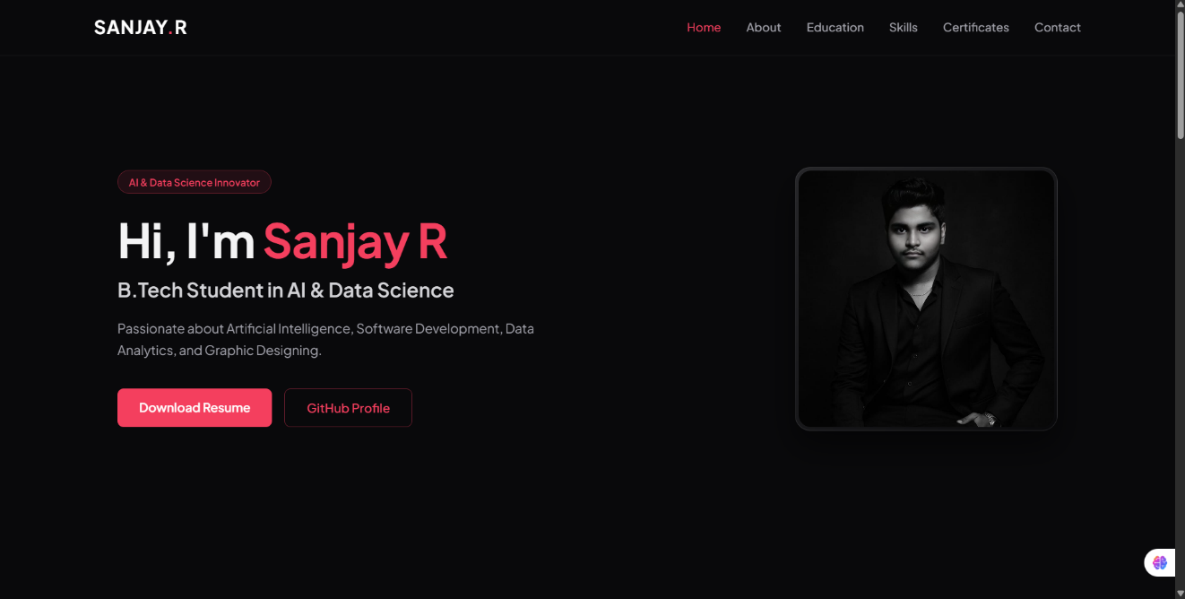
Figure 5.1: Portfolio Homepage
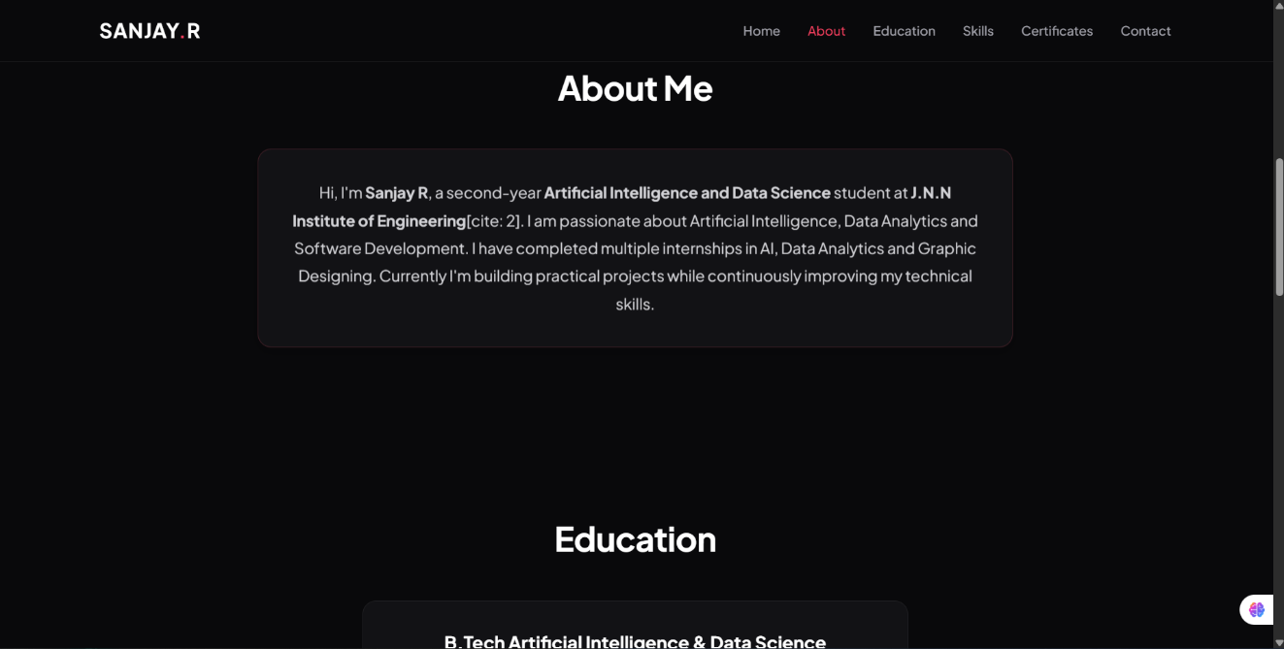
Figure 5.2: About Me Section
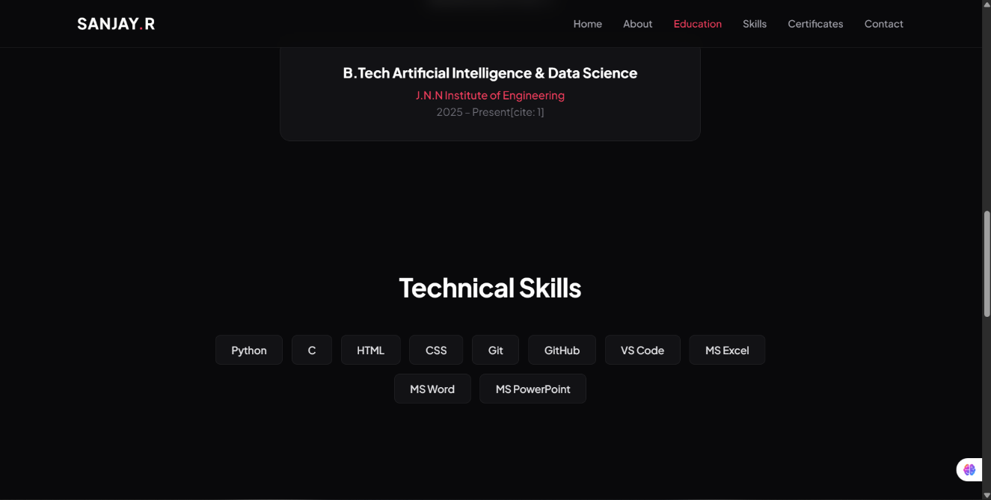
Figure 5.3: Technical Skills Section
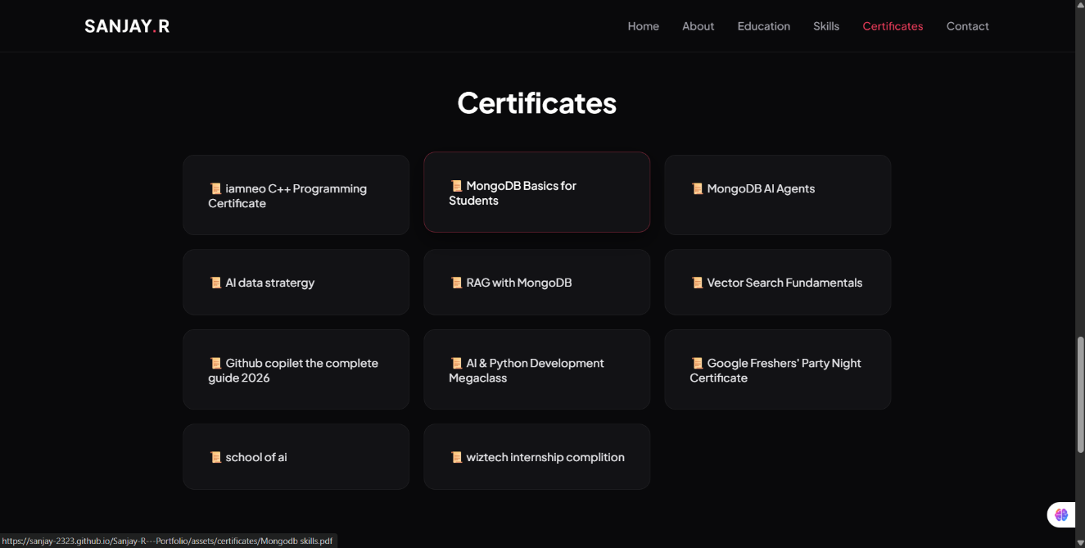
Figure 5.4: Certificate Section
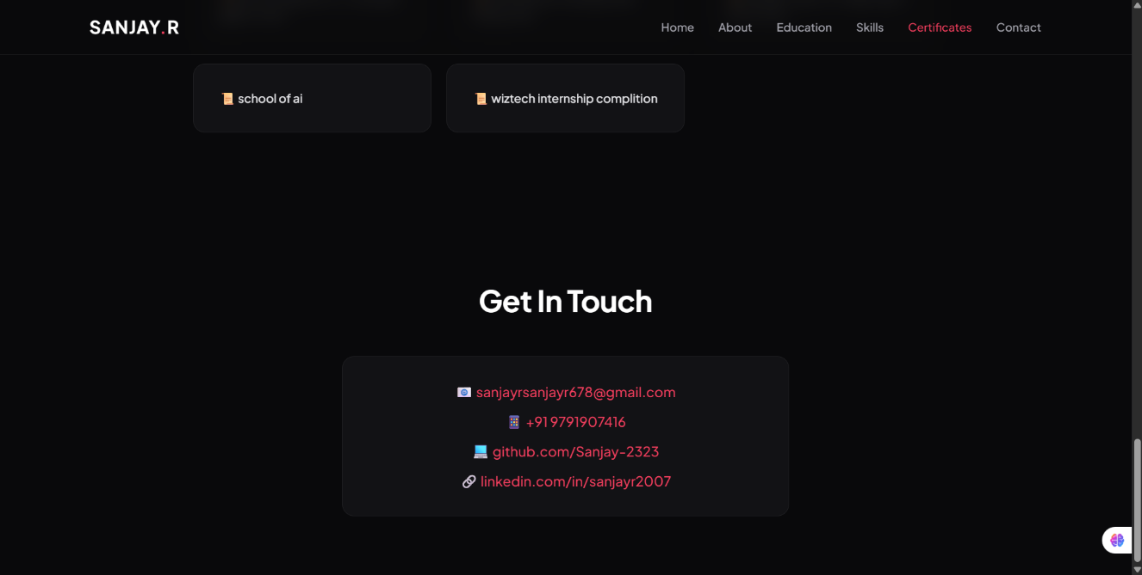
Figure 5.5: Resume and Profile Section
The website also includes contact information, social media links, and a resume download option to help visitors access additional details. CSS styling was applied to improve the visual appearance, alignment, spacing, and layout of the website. JavaScript was incorporated to support interactive features and improve user engagement.
The completed website was uploaded to GitHub and published using GitHub Pages. This made the portfolio accessible online through a web browser without requiring visitors to run the source code locally.
Website Link: https://sanjay-2323.github.io/Sanjay-R---Portfolio/
Overall, the developed portfolio website demonstrates the practical application of web development concepts and provides an online platform to showcase personal information, technical skills, projects, and achievements.

5.2 Features and Functionality
The personal portfolio website was developed with several features to present personal and professional information in an organised manner. These features improve the accessibility of information and provide visitors with a convenient browsing experience. The main features and functionalities of the website are described below.
- Home Section: The home section introduces the portfolio owner and provides an initial overview of the website. It helps visitors understand the purpose of the portfolio.
- About Me Section: This section presents personal information and a brief introduction about the portfolio owner.
- Education Section: The education section displays academic details, helping visitors understand the educational background of the portfolio owner.
- Skills Section: This section highlights technical skills and knowledge related to programming and web development.
- Projects Section: The projects section showcases completed projects and provides information about practical work and technical experience.
- Certificates Section: This section presents certificates and achievements that demonstrate learning activities and professional development.
- Contact Section: The contact section provides relevant contact information so that visitors can connect with the portfolio owner.
- Resume Download and Social Links: The website provides access to the resume and relevant social media profiles, allowing visitors to explore additional professional information.
- Responsive Design: CSS styling techniques help the website adapt to different screen sizes and improve usability across devices.
- Interactive Elements: JavaScript supports interactive behaviour and enhances the overall browsing experience.
These features combine to create a personal portfolio that presents information clearly and provides a convenient way to explore the portfolio owner’s skills, education, projects, and achievements.

5.3 Challenges and Solutions
During the development of the personal portfolio website, several challenges were encountered while designing, implementing, and testing the website. These challenges provided practical learning opportunities and helped improve problem-solving skills.
CSS alignment and layout management. One of the main challenges was CSS alignment and layout management. Arranging different website sections, maintaining proper spacing, and aligning elements consistently required careful adjustments. This issue was addressed by modifying CSS properties and checking the layout in a web browser until the elements appeared properly organised.
Responsive design. Ensuring that the website displayed correctly on different screen sizes required additional testing and adjustments. Suitable CSS styling techniques were applied to improve the layout and make the content easier to view on different devices.
JavaScript implementation and debugging. Some interactive features did not behave as expected initially. These issues were handled by reviewing the code, identifying errors, and making the necessary corrections. Repeated testing helped improve the functionality of the implemented features.
Understanding and organising the code. As the project progressed, it became necessary to review the HTML structure, CSS styling, and JavaScript code carefully to maintain consistency. Using Visual Studio Code helped with editing and managing the project files.
Through these challenges, practical knowledge of web development was strengthened. The project improved understanding of HTML, CSS, and JavaScript and developed the ability to identify errors, test solutions, and work independently. Overall, the challenges encountered during the project contributed to a better understanding of the website development process.

CHAPTER 6
CONCLUSION AND FUTURE WORK

6.1 Conclusion
The web development internship at Wiztech Automation Solutions, Anna Nagar, Chennai, provided valuable practical experience in designing and developing a personal portfolio website. The internship was carried out from 1st August 2026 to 17th August 2026. During this period, the concepts of HTML, CSS, and JavaScript were applied to develop a website that presents personal information, educational qualifications, technical skills, projects, certificates, and contact details.
The project helped develop a better understanding of website structure, styling, responsive design, and interactive features. HTML was used to organise the website content, CSS was applied to improve its visual appearance and layout, and JavaScript was used to support interactive functionality. Visual Studio Code was used for development, while GitHub and GitHub Pages were used to manage the project files and publish the website online.
During the development process, challenges related to CSS alignment, responsive behaviour, and JavaScript debugging were encountered and addressed through code modifications and testing. These experiences improved problem-solving abilities, logical thinking, and confidence in working with web development technologies.
The internship also encouraged independent learning and practical implementation of technical concepts. It provided an opportunity to understand the different stages involved in developing a website, from planning and coding to testing and deployment.
In conclusion, the internship successfully provided practical exposure to web development and helped strengthen the technical knowledge required to create a personal portfolio website. The completed project serves as an online platform to showcase personal information, skills, projects, and achievements while providing a foundation for further learning in web development.

6.2 Future Enhancements
Although the personal portfolio website fulfils its primary purpose of presenting personal and professional information, several enhancements can be introduced in the future to improve its functionality, design, and user experience.
The website can be enhanced by adding more advanced animations and interactive elements to create a more engaging browsing experience. Additional responsive design improvements can also be implemented to ensure consistent presentation across different devices and screen sizes.
In the future, a functional contact form can be integrated with a suitable backend or email service to enable visitors to send messages directly through the website. The projects section can be expanded with more projects, detailed descriptions, source code links, and live demonstrations to showcase practical technical skills.
The website can also be improved by adding a dedicated blog section to share technical knowledge, learning experiences, and project updates. Search engine optimisation (SEO) techniques can be applied to improve the website’s visibility in search results. Further improvements in accessibility, loading speed, and website security can also be considered.
Another possible enhancement is to integrate a content management system that allows website information to be updated more easily without modifying every section manually. New technologies and frameworks can also be explored as part of future learning and development.
These enhancements can help transform the personal portfolio website into a more comprehensive professional platform. Continuous improvement and regular updates will help keep the portfolio relevant and useful for showcasing future projects, skills, certifications, and achievements.

INTERNSHIP CERTIFICATE
